**NITTE MEENAKSHI INSTITUTE OF TECHNOLOGY**

(AN AUTONOMOUS INSTITUTION)

(AFFILIATED TO VISVESVARAYA TECHNOLOGICAL UNIVERSITY, BELGAUM, APPROVED BY AICTE & GOVT.OF KARNATAKA)



**WEB TECHNOLOGY PROJECT**

**ON**

**“PHARMACEUTICALS WEBSITE”**

***SUBMITTED BY:***  **USN:**

MOHAN SAI KIRAN B 1NT16CS056

PAWAN R TANKSALI 1NT16CS070

*Submitted in partial fulfillment of the requirement for the completion of the V semester Web Technology Project for the year 2018-2019*

Department of Computer Science and Engineering

NitteMeenakshi Institute of Technology,

Yelahanka, Bangalore– 560064

Academic Year 2018-2019

**NITTE MEENAKSHI INSTITUTE OF TECHNOLOGY**

(AN AUTONOMOUS INSTITUTION)

(AFFILIATED TO VISVESVARAYA TECHNOLOGICAL UNIVERSITY, BELGAUM, APPROVED BY AICTE & GOVT.OF KARNATAKA)



**CERTIFICATE**

**This is to certify that the Web Technology Project Report entitled**

**“PHARMACEUTICALS WEBSITE”**

is an authentic work carried out by,

***SUBMITTED BY:***  **USN:**

MOHAN SAI KIRAN 1NT16CS056

PAWAN R TANKSALI 1NT16CS070

In partial fulfillment of the requirements for the completion of V semester Web Technology Project for the academic year 2018-2019.

Name & Signature of the Guide Name & Signature of HOD

**Ms. Impana P Dr. Thippeswamy M N**

**ACKNOWLEDGEMENT**

The satisfaction and euphoria that accompany the successful completion of any task would be incomplete without the mention of people who made it possible, whose constant guide and encouragement crowned our efforts with success.

We would like express our gratitude to our **Principal**, **Dr. H C NAGARAJ**.

We would like to thank our **HOD, Dr. Thippeswamy M N** for his valuable support without which this project would not have been possible.

We would also like to express our greatest thanks to our guide, **Ms. Impana P** for giving us such a concept to work on and for her valuable effort, support and guidance without which this project would not have been possible.

We would like to thank our friends and parents for providing inspiration to successfully complete the project.

We would like to mention special thanks to the staff of **CSE Department, NMIT** for their support.

**ABSTRACT**

Now a day’s Information and communication technology (ICT) plays a great role in different fields and the Health care system belongs to this. This leads to various studies and researches being conducted to selected health care facilities. It is necessary to ensure a technologically appropriate, equitable, affordable and environmentally adaptable and consumer friendly system, designed to fully utilize the ICT for maximum benefit.

Here computers have great relevant on storing data’s securely and ease access on them in short period of time. For this access of data we use Databases either in a local server or a web server. To access all this data we use a webpage that is responsive and is easily accessible.

The Pharmacy website is robust, integrated and easily usable for everyone. Pharmacy website deals with maintenance of drugs in the databases and the properties or the details of the drugs like their batch number, expiry date, manufacture date, dosage, etc. The website will ensure the availability of sufficient quantity of drugs and consumable materials for the patient. This will enhance the efficiency of clinical work and ease patient’s convenience and providing a better care for the patients.

This project is an introduction or just a basic beginning of the Pharmaceuticals website where the Database platform is “MySQL” and have used Web Tech languages like HTML, PHP and JavaScript.

**TABLE OF CONTENTS**

|  |  |  |
| --- | --- | --- |
| **Sl.No** | **Description** | **Page No.** |
|  | INTRODUCTION  1.1 OBJECTIVE | 1 |
|  | SYSTEM REQUIREMENTS | 2 |
|  | IMPLEMENTATION | 3 |
|  | RESULS AND SNAPSHOTS | 7 |
|  | CONCLUSION AND FUTURE ENHANCEMENTS | 13 |
| 6. | REFERENCES | 14 |

# INTRODUCTION

**PHP** (PHP: Hypertext Preprocessor) is a [scripting language](https://simple.wikipedia.org/wiki/Scripting_language) that helps people make web pages more interactive by allowing them to do more things. PHP code is run on the web server.

A website programmed with PHP can have pages that are password protected. A website with no programming cannot do this without other complex things. Standard PHP [file extensions](https://simple.wikipedia.org/wiki/File_extension) are: .php .php3 or .phtml, but a web server can be set up to use any extension.

Its structure was influenced by many languages like [C](https://simple.wikipedia.org/wiki/C_programming_language), [Perl](https://simple.wikipedia.org/wiki/Perl), [Java](https://simple.wikipedia.org/wiki/Java_programming_language), [C++](https://simple.wikipedia.org/wiki/C%2B%2B), and even [Python](https://simple.wikipedia.org/wiki/Python_(programming_language))

**JavaScript** is a [high-level](https://simple.wikipedia.org/wiki/High-level_programming_language), interpreted [programming language](https://simple.wikipedia.org/wiki/Programming_language) for [computers](https://simple.wikipedia.org/wiki/Computer). It is often run in [web browser](https://simple.wikipedia.org/wiki/Web_browser) applications to create things that works by themselves like a popup message or a live [clock](https://simple.wikipedia.org/wiki/Clock). It is not related to the [programming language](https://simple.wikipedia.org/wiki/Programming_language) [Java](https://simple.wikipedia.org/wiki/Java_programming_language).

Although Java and JavaScript have many external similarities such as name and syntax, the two languages follow different design principles.

**MySQL** is a [database](https://simple.wikipedia.org/wiki/Database) [system](https://simple.wikipedia.org/wiki/System) used by many [websites](https://simple.wikipedia.org/wiki/Websites) on the [Internet](https://simple.wikipedia.org/wiki/Internet). It is based off of [SQL](https://simple.wikipedia.org/wiki/SQL). Many ways of doing things in SQL are similar in MySQL. MySQL is compatible with many major [programming languages](https://simple.wikipedia.org/wiki/Programming_language). The most common one is [PHP](https://simple.wikipedia.org/wiki/PHP). An [ODBC](https://simple.wikipedia.org/w/index.php?title=ODBC&action=edit&redlink=1) interface (called [MyODBC](https://simple.wikipedia.org/w/index.php?title=MyODBC&action=edit&redlink=1)) has been made so that users of [Microsoft](https://simple.wikipedia.org/wiki/Microsoft)'s [ASP](https://simple.wikipedia.org/w/index.php?title=ASP&action=edit&redlink=1) language can use MySQL.

## 1.1 OBJECTIVE

The main purpose of this project is to simplify the process of searching and adding medicine by providing a web interface for admin and user.

Listed below are the modules which will be included and further modifications can take place

1. To insert a new medicine with the appropriate details.

2. To update medicine details.

3. To remove medicine details.

4. To show medicine details.

5. To search for a particular medicine.

**SYSTEM REQUIREMENTS**

**SOFTWARE REQUIREMENTS:**

* HTML/CSS
* PHP
* MySQL Database
* XAMPP server
* JavaScript
* Notepad++
* Google Chrome or any other Browsers
* Windows or a Ubuntu operating system

**HARDWARE REQUIREMENTS:**

* Processor –Core i3+
* Hard Disk – 160 GB+
* Memory – 1GB RAM+
* Monitor

**IMPLEMENTATION**

PHP can be used to connect to and manipulate databases. MySQL is the most popular database system used with PHP. PHP combined with MySQL are cross-plat.

**PHP Connect to MySQL:**

Before we can access data in the MySQL database, we need to be able to connect to the server.

* **session_start():**

creates a session or resumes the current one based on a session identifier passed via a GET or POST request, or passed via a cookie.

* **mysqli_connect():**

The mysqli_connect() function opens a new connection to the MySQL server.

SYNTAX:

**mysqli_connect(host,username,password,dbname,port,socket)*;***

EXAMPLE:

mysqli_connect(“localhost”, “root”, “123”,”registration”);

* **isset():**

The isset () function is used to check whether a variable is set or not. If a variable is already unset with unset() function, it will no longer be set.

SYNTAX:

isset(variable1, variable2......)

EXAMPLE:

<?php

$var1 = 'test';

var_dump(isset($var1));

?>

OUTPUT:

bool(true)

* **mysqli_real_escape_string():**

The mysqli_real_escape_string() function escapes special characters in a string for use in an SQL statement.

SYNTAX:

**mysqli_real_escape_string(connection,escapestring)*;***

EXAMPLE:

mysqli_real_escape_string($db, $_POST['username'])

* **mysqli_query():**

The mysqli_query() function performs a query against the database.

SYNTAX:

mysqli_query(*connection,query,resultmode*)*;*

EXAMPLE:

$user_check_query = "SELECT * FROM users WHERE username='$username' OR email='$email' LIMIT 1";

$result = mysqli_query($db, $user_check_query);

* **mysqli_fetch_assoc():**

The mysqli_fetch_assoc() function fetches a result row as an associative array.

SYNTAX:

mysqli_fetch_assoc(*result*)

EXAMPLE:

$user_check_query = "SELECT * FROM users WHERE username='$username' OR email='$email' LIMIT 1";

$result = mysqli_query($db, $user_check_query);

$user = mysqli_fetch_assoc($result);

* **mysqli_num_rows():**

The mysqli_num_rows() function returns the number of rows in a result set

SYNTAX:

mysqli_num_rows(*result*)*;*

EXAMPLE:

$results = mysqli_query($db, $query);

if (mysqli_num_rows($results) == 1)

echo”Hi”;

* **$_SESSION:**

A session is a way to store information (in variables) to be used across multiple pages.

SYNTAX:

$_SESSION[variable name];

EXAMPLE:

$_SESSION[‘counter’];

* **$_GET[]:**

The $_GET variable is used to get data from a form that is written in HTML.Before you can use the the $_GET variable you have to have a form in html that has the method equal to GET.

SYNTAX:

$_GET[variable name];

EXAMPLE:

$_GET[‘counter’];

* **$_POST[]:**

The $_POST variable is also used to collect data from forms, but the $_POST is slightly different because in $_GET it displayed the data in the url and $_POST does not. Before you can use the the $_POST variable you have to have a form in html that has the method equal to POST.

SYNTAX:

$_POST[variable name];

EXAMPLE:

$_POST[‘counter’];

**JAVASCRIPT:**

JavaScript can be implemented using JavaScript statements that are placed within the **<script>... </script>**. You can place the **<script>** tags, containing your JavaScript, anywhere within your web page, but it is normally recommended that you should keep it within the **<head>** tags.

# document.getElementsByName():

The getElementsByName() method returns a collection of all elements in the document with the specified name (the **value** of the name attribute), as a NodeList object.

SYNTAX:

**document.getElementsByName(*name*);**

EXAMPLE:

document.getElementsByName(*‘fname’*);

## JavaScript Function:

A JavaScript function is defined with the **function** keyword, followed by a **name**, followed by parentheses **()**.

SYNTAX:

function name(parameter1, parameter2, parameter3) {

code to be executed

}

EXAMPLE:

function myFunction(a, b) {

return a * b; // Function returns the product of a and b

}

* **JAVASCRIPT EVENTS:**

JavaScript's interaction with HTML is handled through events that occur when the user or the browser manipulates a page. When the page loads, it is called an event. When the user clicks a button, that click too is an event. Other examples include events like pressing any key, closing a window, resizing a window, etc.

* **onsubmit Event type:**

onsubmit is an event that occurs when you try to submit a form. You can put your form validation against this event type.

SYNTAX:

<*element* onSubmit="*myScript*">

EXAMPLE:

<form onSubmit=”myfunc”>

* **focus():**

The focus() method is used to give focus to an element (if it can be focused).

SYNTAX:

*HTMLElementObject*.focus();

EXAMPLE:

id.focus();

**RESULTS AND SNAPSHOTS**

“Pharmaceutical website” mainly focusses on inserting, deleting, updating and displaying medicine details.

This project front end is developed using HTML, PHP, CSS and backend is developed using “MySQL”.

**LOGIN PAGE:**

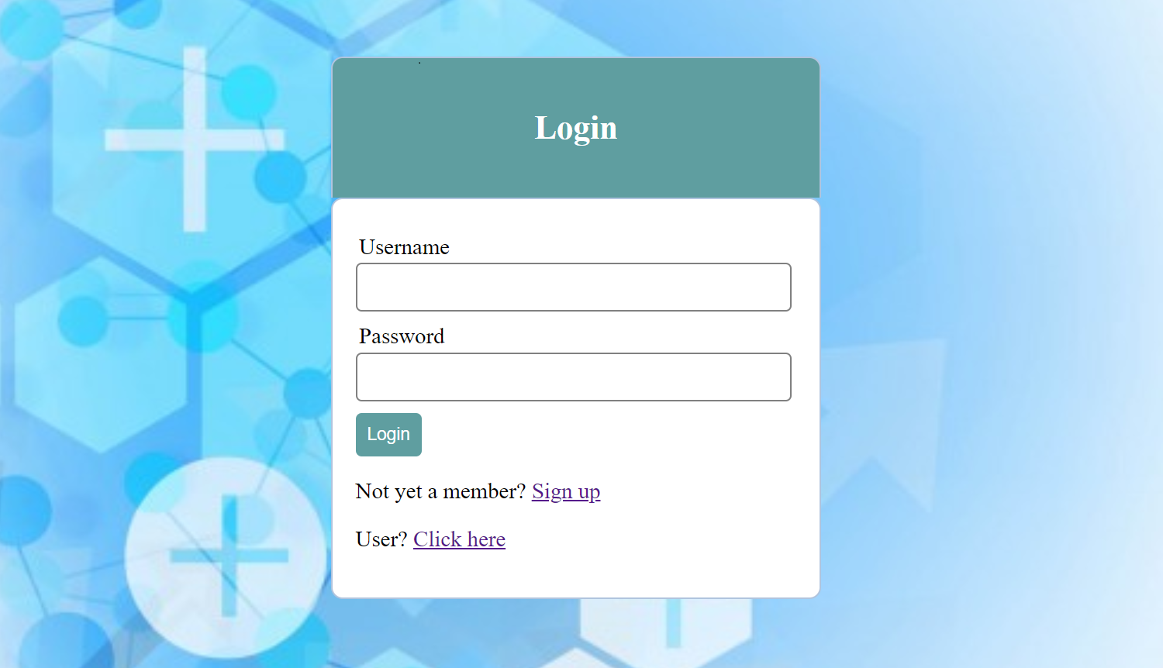

Fig 1: Login page

Upon entering the website login page appears with username and password fields to enter. If the person is an administrator then he/she can provide the login credentials and if the person is not registered he/she can register. It also consists of a link for normal user operations

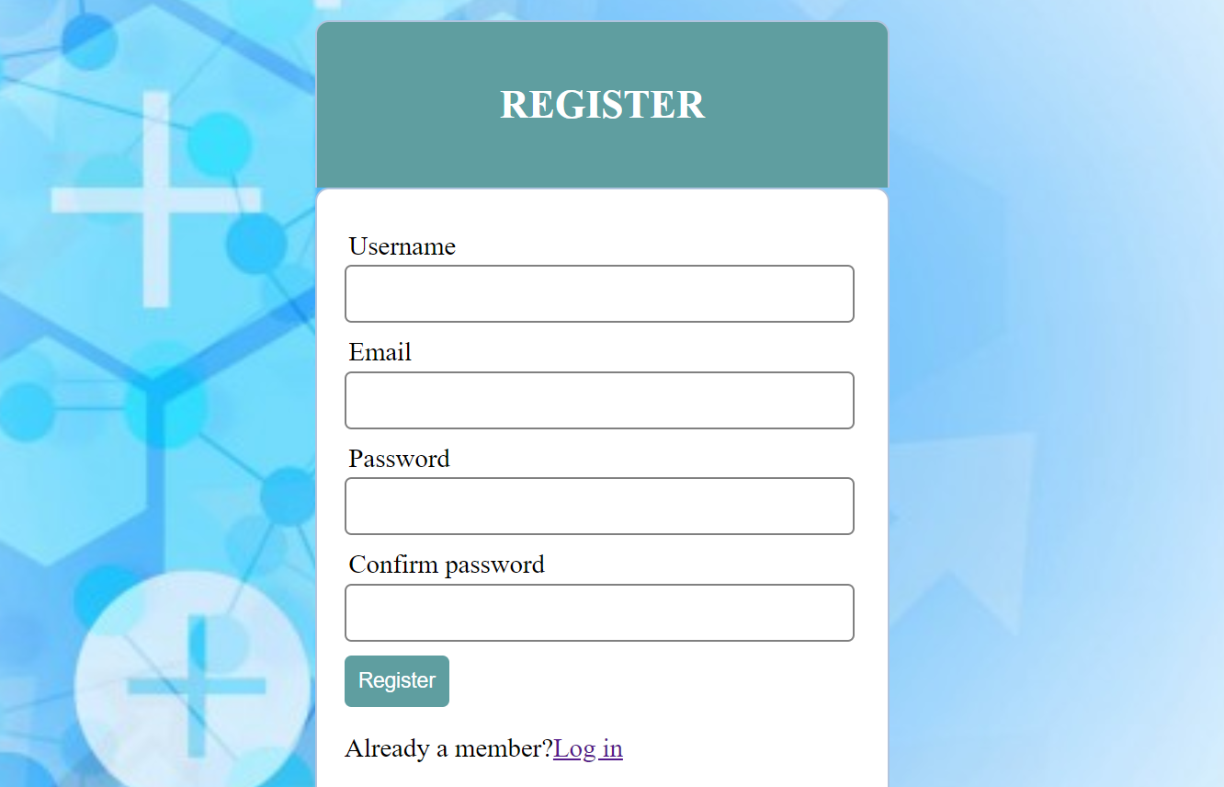

Fig 2: Registration

If the person is not registered as an admin then he/she will be provided with a registration form which prompts to enter all the valid details. If the person is already a member and already registered then he/she may proceed with the login.

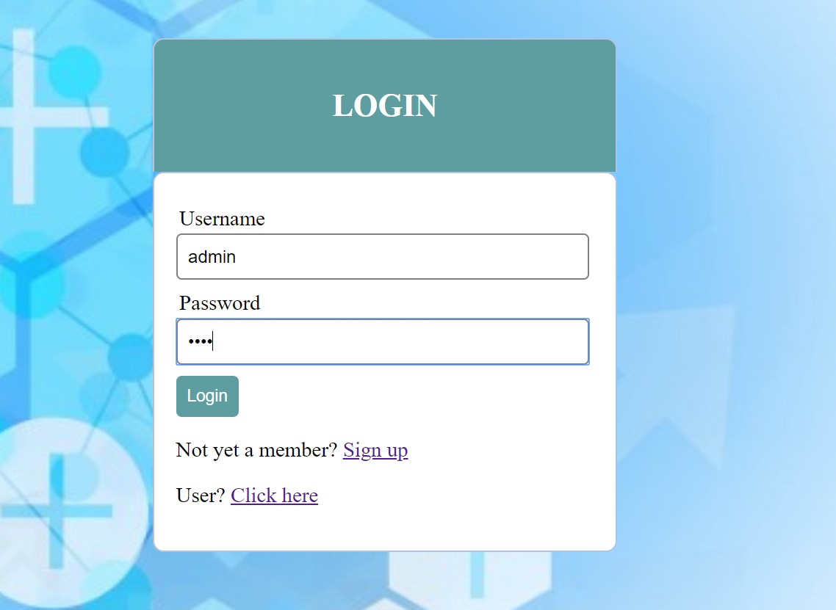

Fig 3: Registered admin login

The administrator who is already registered and a member will be provided with a login page wherein they have to enter the username and password.

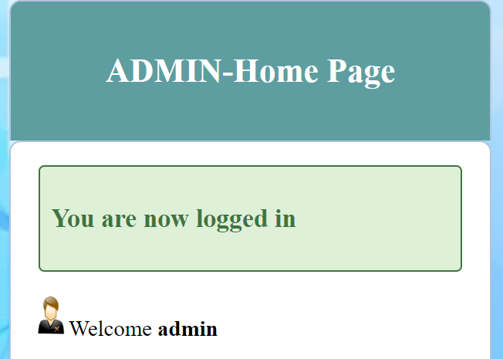

Fig 4: Admin home page

On providing correct credentials the admin will be taken to the home page where admin can perform various operations.

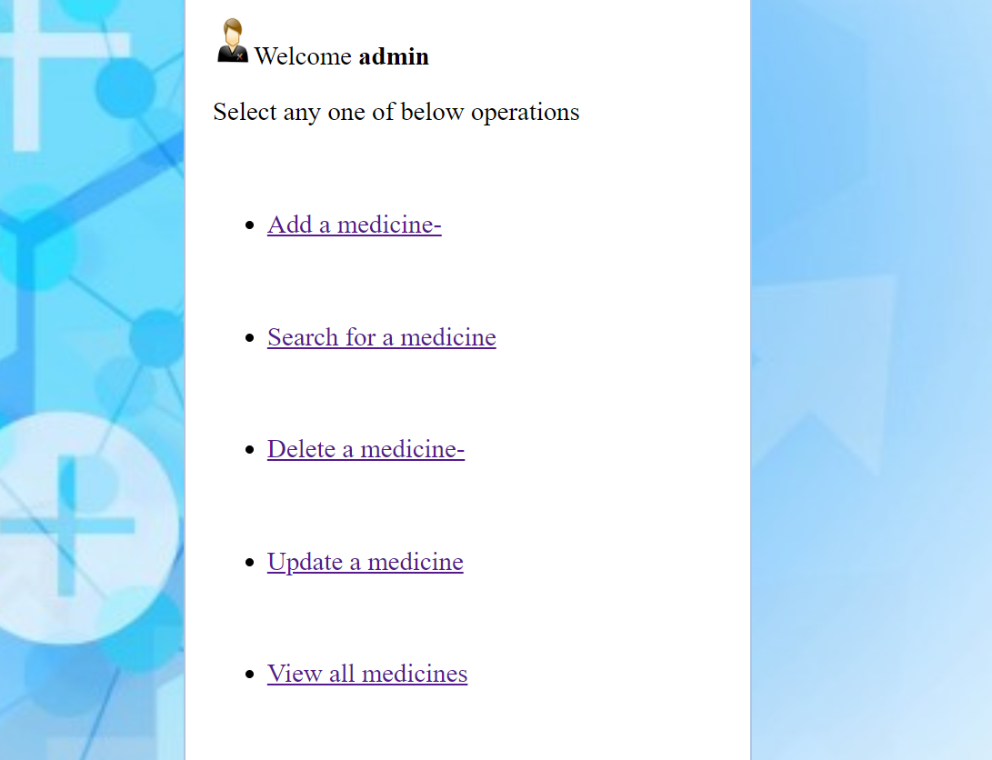

Fig 5: Admin operations

Figure shows the various operations that the administrator can perform such as adding a medicine,deleting a medicine,updating a medicine,search and to view all the medicines.

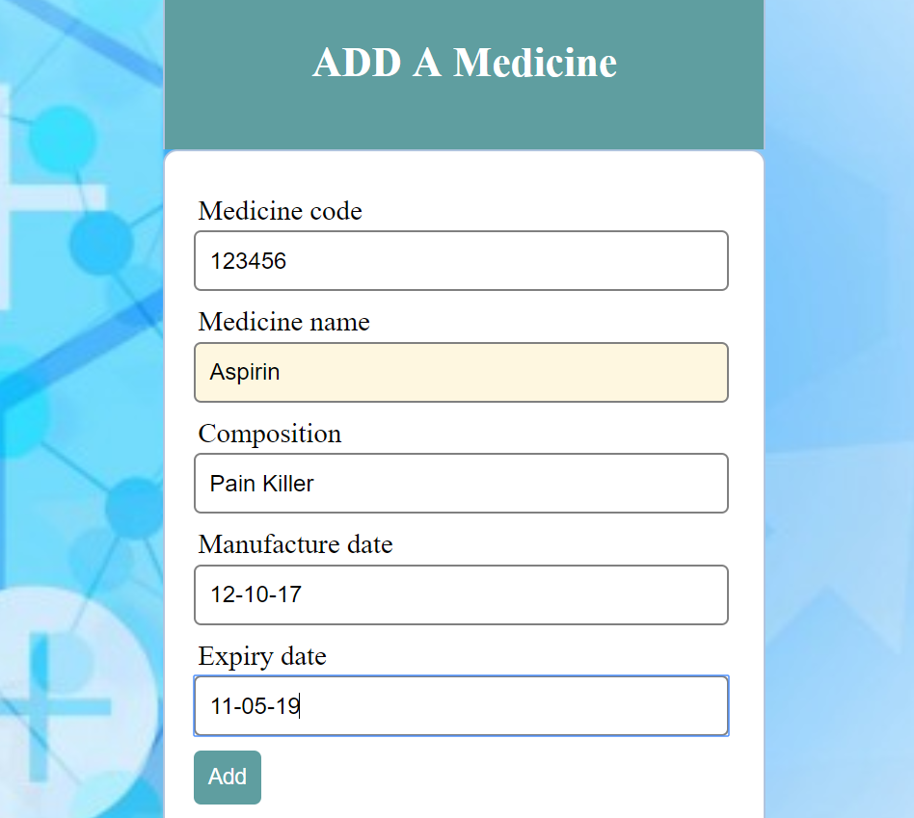

Fig 6: Add a medicine

Figure shows insertion of a medicine details like medicine code,medicine name,composition,manufacture date and expiry date.

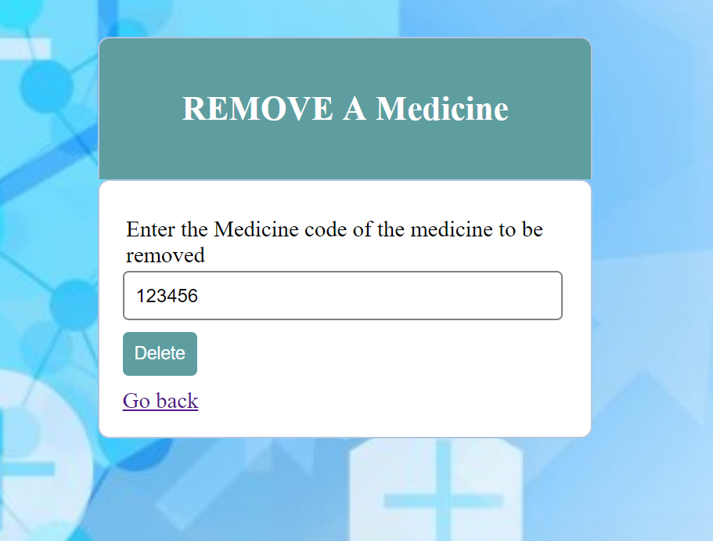

Fig 7: Delete a medicine

Figure shows the deletion of a medicine using the medicine code

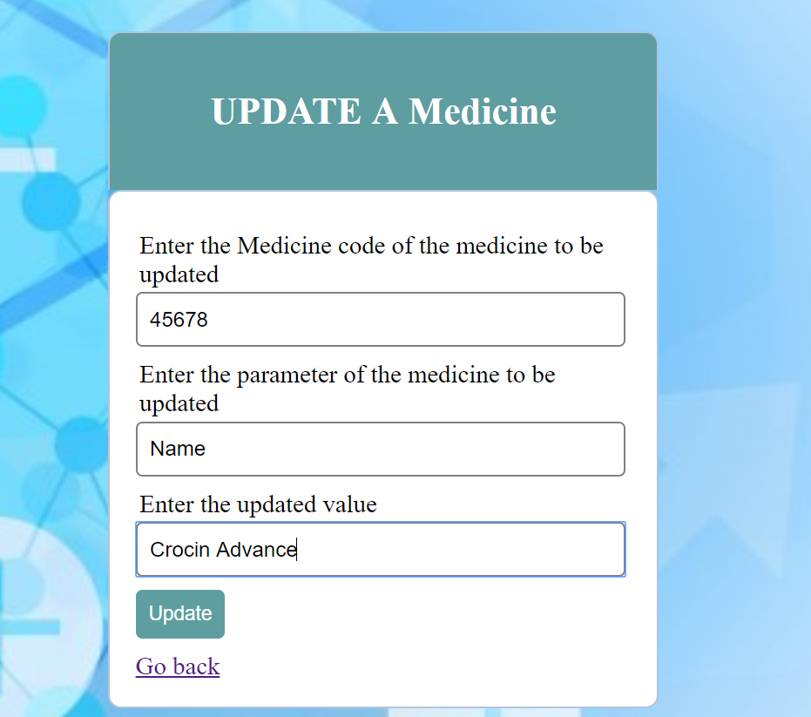

Fig 8: Updating a medicine

Figure shows the updation of a medicine using medicine code we enter the parameter to be changed and the updated value.

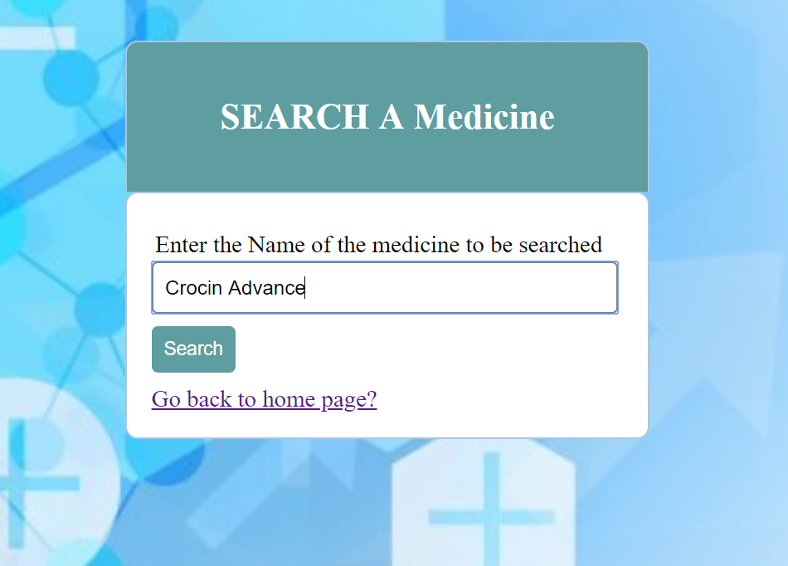

Fig 9: Search for a medicine

Figure shows the searching for a medcine using the name of the medicine.

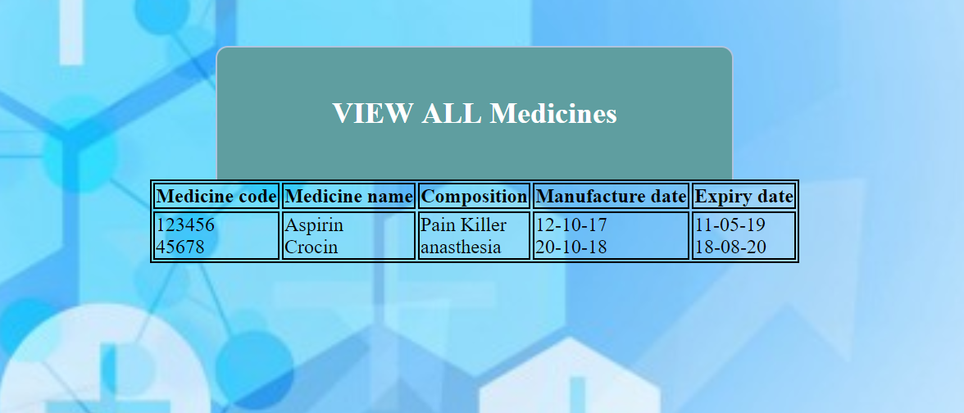

Fig 10: Display of all the medicines

Figure shows the entries of all the medicines along with their details

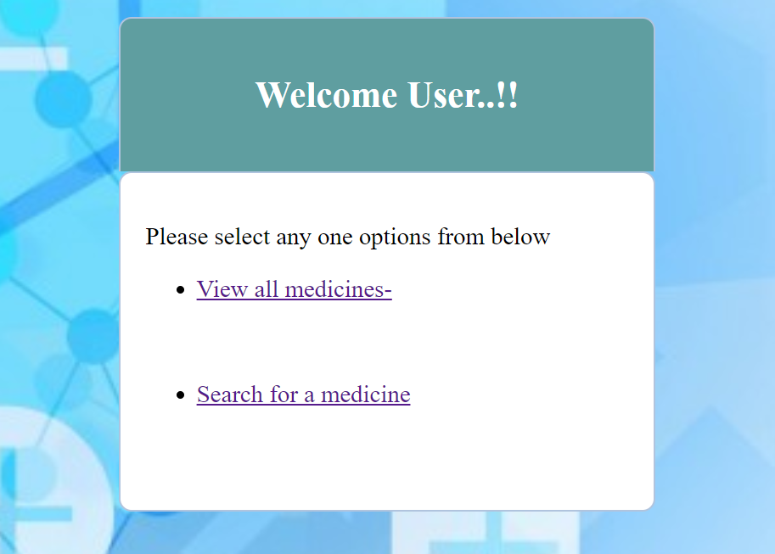

Fig 11: User page

Figure shows the page for the users who wishes to view all the medicines as well as search for a medicine.

# CONCLUSION AND FUTURE ENHANCEMENT

From this project, we have learnt the importance of the Web Tech languages and Database platforms. There are numerous benefits from learning these languages, however the most important benefit is that being in a century where people are heading towards ‘Digital World’, this project helps people in simplifying their lives.

We have also, through this project understood the working of the above-mentioned concepts to a thorough extent. We have learnt different tip and tricks in coding and using the multiple languages as a powerful tool in making the understanding of Web Tech languages easier.

The project will be helpful for pharmacist to automate the system instead of maintaining manual records and is also very user friendly to run various queries.

# 

# REFERENCES

1. <https://www.w3schools.com>

* HTML
* PHP
* CSS
* JS

1. <https://stackoverflow.com/>